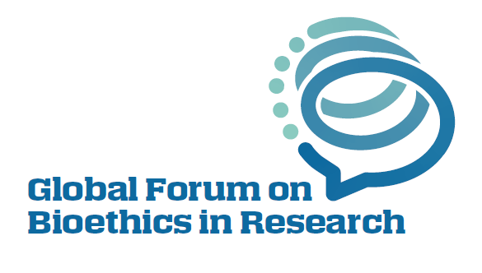

PARTICIPANT

APPLICATION FORM
Montreux, Switzerland, 28&29 November 2023

Fields marked with an asterisk (*) are required.
Please type your answers. Where there are multiple options, specify your choice with an X

APPLICANT CONTACT INFORMATION
Last Name*  (Surname) |  | First Name* (Given) |  | Middle Name
Affiliation*
(Name and address of the organization where you primarily work or study, no abbreviations)
Institution type* | University/Academic Research Institution Government  Private Sector Philanthropy/Donor  Non-profit/non-governmental Other__________
Title* (e.g. Mr, Ms, Dr, Prof etc)
Your position*
Your career stage* | Early (0-10 years) Mid (11-20 years) Senior (21+ years)
In which country are you based? *
In which region are you based? * | African  Eastern Mediterranean  Europe  Americas  South-East Asia  Western Pacific
Which most closely describes your gender? | Woman  Man  Non-binary  Gender not listed. My gender is __________  Prefer not to state
Do you require funding to cover travel and accommodation costs?*  Note  Funding is prioritised for applicants from LMICs. | Yes  No, I will self-fund
Areas of expertise*  (check all that apply) | Area of expertise:  Bioethics, research ethics or philosophy  Law  Regulatory or policy making  Public health  Medical or health sciences  Behavioral and social sciences  Biological, physical or earth sciences  Epidemiology  Computer or data science  Medicine and healthcare  Stakeholder engagement  Journalism  Other (please describe): ____________
Name and contact details for two referees*

APPLICANT LANGUAGE INFORMATION
English Proficiency* | Native/bilingual proficiency  Full professional proficiency  Professional working proficiency  Limited working proficiency  Elementary proficiency  No proficiency
What is your preferred language (If not English)?
Please note that the forum is held in English and the expectation is that presenters present in English. If this causes you difficulty and you need language assistance, please state this here:

Instructions: In the spaces below, please provide thorough but brief responses to each component of the application narrative. Your narrative responses may not exceed the length indicated for each section and must be completely contained inside the text boxes. All answers must be typed, in English, single-spaced and no less than Arial 10pt font.

Why do you want to participate in the Global Forum on Bioethics in Research?*
(150-word limit)

Briefly describe your interest in, or experience of, the ethics of health research priority setting.* (250-word limit)

What would you uniquely contribute to the Global Forum on Bioethics in Research meeting as a participant? How would you disseminate the meeting outcomes to your institution and local/regional partners? * (350-word limit)

Data protection consent

I hereby confirm my consent to the World Health Organization (WHO) collecting and processing my personal data for the purposes of the forthcoming GFBR, including determining the suitability and eligibility of my application to attend GFBR and/or to be a speaker/member of a panel at the Forum, registration and managing attendance, making logistical arrangements (including travel and accommodation arrangements), event follow-up, preparing statistics of global event participation by region, and sending follow-up materials to participants.

In addition, I consent to WHO collecting and processing my personal data for the following specific purposes:
- For the purposes of the discussion groups that will meet during the two days of the Forum, the name, institute and country of residence of group members will be shared with the discussion group chairs (members of the Planning and Steering Committee) in advance of the Forum.

- The personal data of presenters will be shared with the member of the Planning Committee, who has been delegated to mentor them to develop their case study write-up and presentation. The final papers and presentations (which contain name, institute, country) are shared with all Forum attendees.

- For the purpose of oversight, the GFBR Steering Committee will receive a summary list of attendees (name, institute, country, area of expertise and career stage).

*WHO’s personal data protection framework includes the WHO Privacy Policy available at https://www.who.int/about/who-we-are/privacy-policy) and the UN Personal Data Protection and Privacy Principles, which are available at the following link: https://archives.un.org/sites/archives.un.org/files/_un-principles-on-personal-data-protection-privacy-hlcm-2018.pdf”

I understand that I have the right, as data subject, to access data relating to me, to be informed about the existence and the extent of data processing, to rectify incorrect personal data, to restrict the data processing and to oppose further processing on serious and legitimate grounds. I can exercise these rights by contacting the person in charge of this processing operation (gfbr@who.int).

Signature: ....................................
Note: if it is not possible for you to sign and scan the form please write your name instead.

Date: ...........................

